LAB ASSIGNMENT – 1
Q) Write a Java Program to add two numbers
A)
INPUT: Two numbers
OUTPUT: Sum of two numbers
import java.io.*;
public class AddTwoNum{
public static void main(String[] args) throws Exception{
DataInputStream dis = new DataInputStream(System.in);

System.out.print("Enter First Number: ");
int num1 = Integer.parseInt(dis.readLine());
System.out.print("Enter Second Number: ");
int num2 = Integer.parseInt(dis.readLine());
int sum = num1+ num2;
System.out.print("Sum: " + sum);
}
}
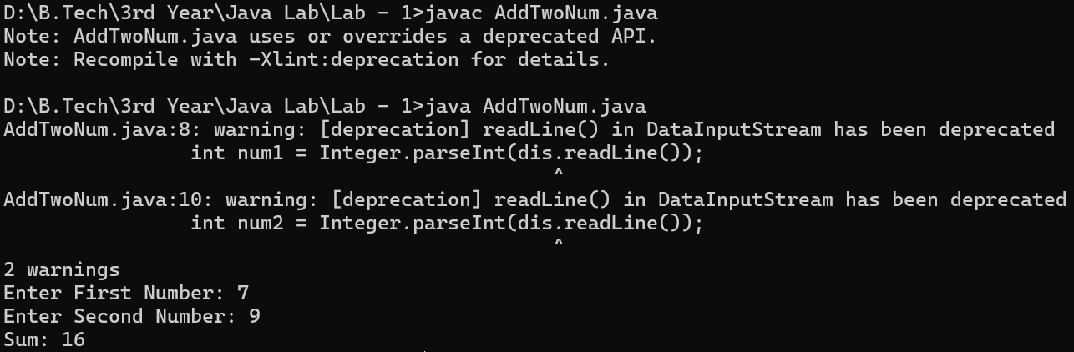
Q) Write a Java Program to separate int and fraction from a float value
A)
INPUT: Float number
OUTPUT: Fractional part and integer part of the number
import java.io.*;
public class IntAndFloatSeparation{
public static void main(String[] args) throws IOException {
DataInputStream dis = new DataInputStream(System.in);

System.out.print("Enter float number: ");
float a = Float.parseFloat(dis.readLine());
int b = (int) a;
float c = a - b;

System.out.println("Integer Part: " + b);
System.out.println("Fractional part: " + c);
}
}
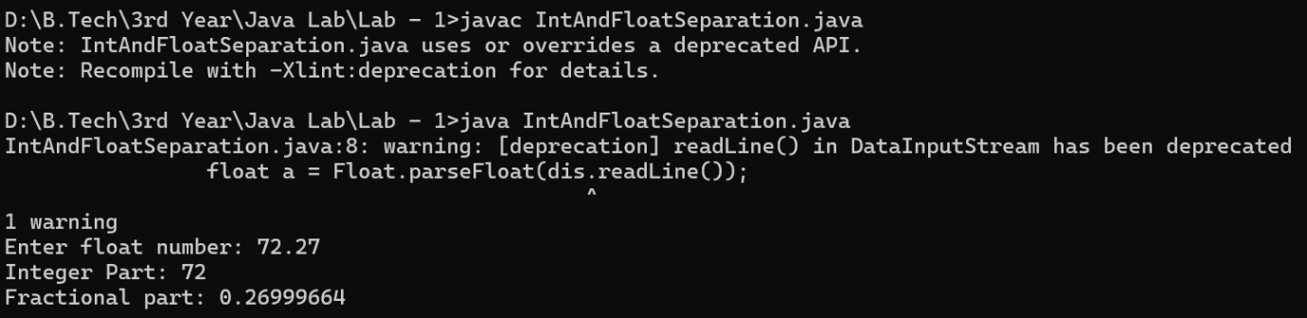
Q) Write a Java Program to find a Fibonacci number using do-while for a given number
A)
INPUT: A number
OUTPUT: Fibonacci number of the number provided by user
import java.io.*;
public class Fibonacci{
public static void main(String[] args) throws IOException{
DataInputStream dis = new DataInputStream(System.in);
System.out.print("Enter a number to find it's Fibonacci number: ");
int num = Integer.parseInt(dis.readLine());
int first = 0, second = 1, count = 2, fib = 0;
if(num < 0){
System.out.println("Number should not be negative");
} else if (num == 0){
fib = 0;
} else if (num == 1){
fib = 1;
} else {
do{
fib = first + second;
first = second;
second = fib;
count++;
} while (count <= num);
System.out.println("Fibonacci number: " + fib);
}
}
}
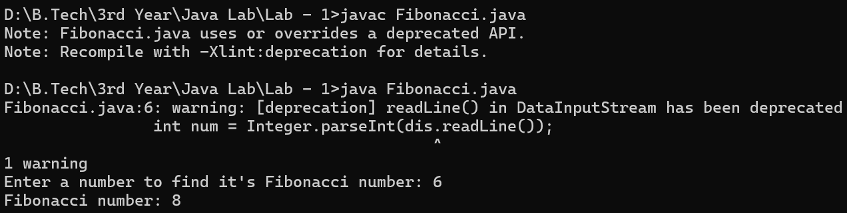
Q) Write a Java Program to find the factorial using for loop
A)
INPUT: A number to find factorial
OUTPUT: Factorial of the number provided by user
import java.io.*;
public class factorial{
public static void main(String[] args) throws IOException{
DataInputStream dis = new DataInputStream(System.in);

System.out.print("Enter a number to find it's factorial: ");
int n = Integer.parseInt(dis.readLine());
int fac=1;
if(n<0){
System.out.print("Enter a valid integer");
} else if(n == 0){
fac = 1;
} else if(n == 1){
fac = 1;
} else{
for(int i=2; i<=n; i++){
fac = fac * i;
}
}
System.out.println("Factorial of " + n + ": " + fac);
}
}
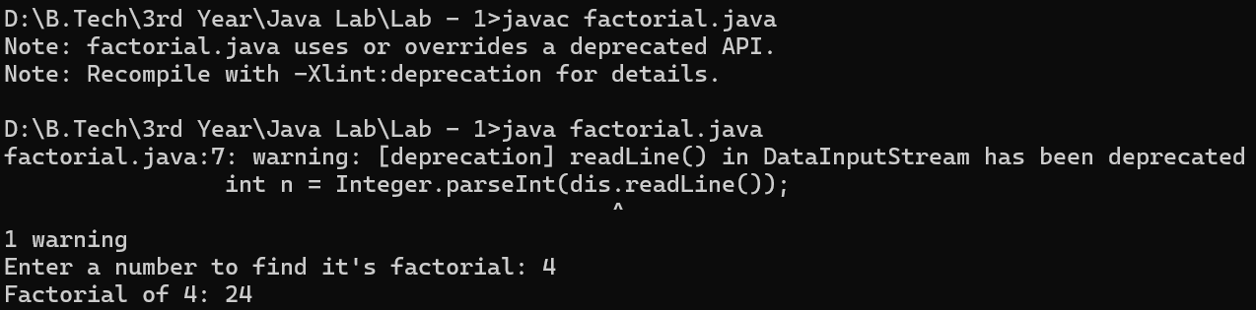

Q) Write a Java Program to check whether the given number is Armstrong number or not using while loop
A)
INPUT: A number to find it’s Armstrong number
OUTPUT: Tells whether the given number by user is an Armstrong number or not
import java.io.*;
public class armstrong{
public static void main(String[] args) throws IOException{
DataInputStream dis = new DataInputStream(System.in);

System.out.print("Enter a number: ");
int num = Integer.parseInt(dis.readLine());
int originalNum = num;
int result = 0;
int n = 0;
int temp = num;

while (temp != 0) {
temp = temp / 10;
n = n + 1;
}

temp = num;

while (temp != 0) {
int digit = temp % 10;
int power = 1;

int count = 0;
power = 1;
while (count < n) {
power = power * digit;
count = count + 1;
}

result = result + power;
temp = temp / 10;
}

if (result == originalNum) {
System.out.println(originalNum + " is an Armstrong number.");
} else {
System.out.println(originalNum + " is NOT an Armstrong number.");
}
}
}
